**Using SAE15 Word Processing Program**

**Step 1: Open the python file**

* Open the python file with an application (VSCde, Spyder...)
* Change directions:

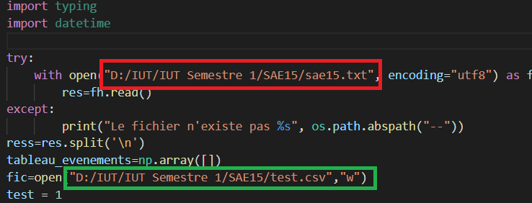

In red please indicate the path from where the file to be scanned is located

In green please indicate the path and name of the Excel file that will contain the sorteddata.

* Change the end data

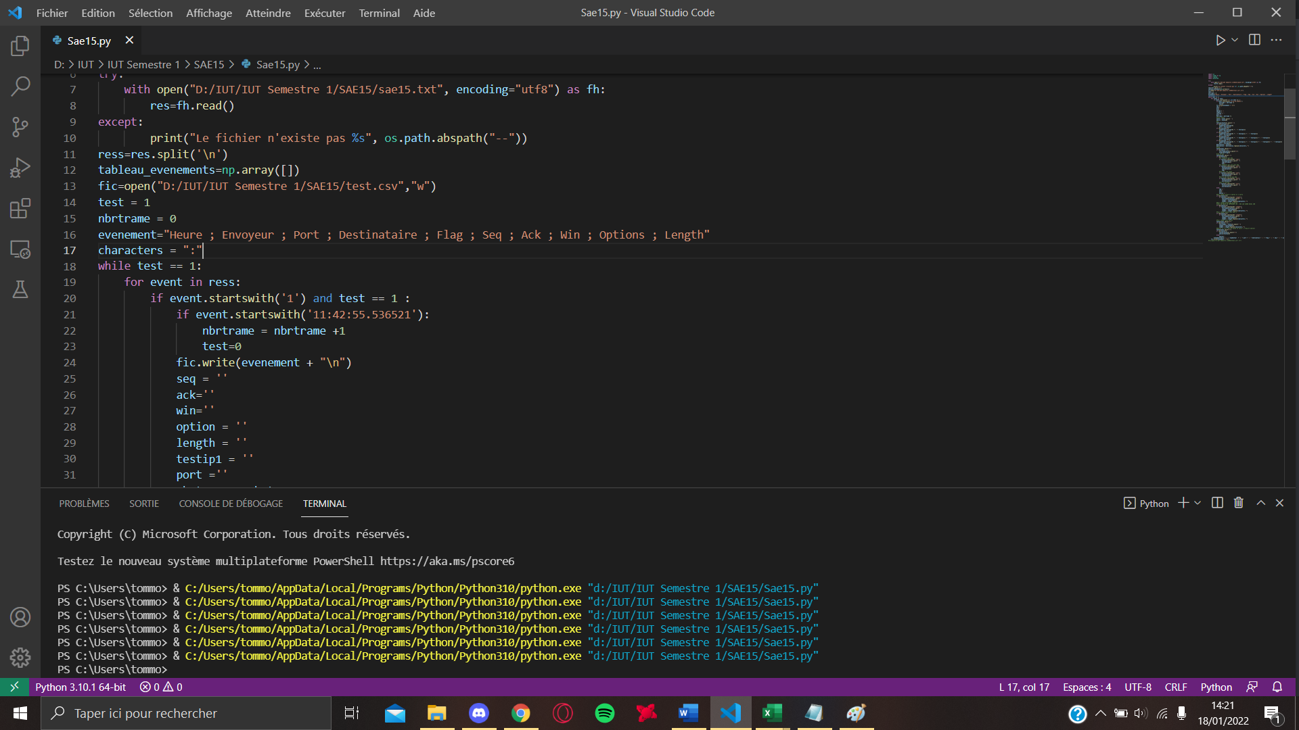

To find this value has modified open the file .txt that contains the document used go to the very bottom of this file and take the value here:

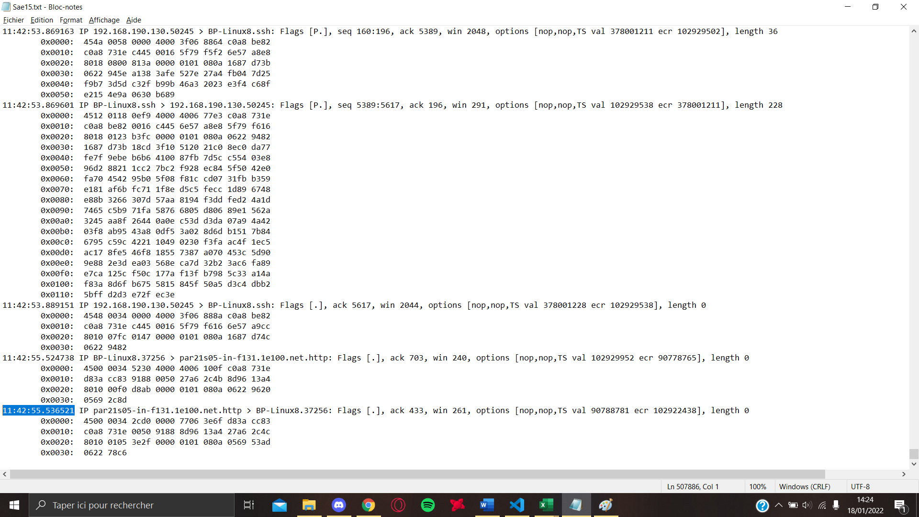



Copy paste it then into the box in Red present previously.

* Launch your program

The way to run your program differs depending on the software but remains very simple, on VSCode you just click on the button highlight in Red.

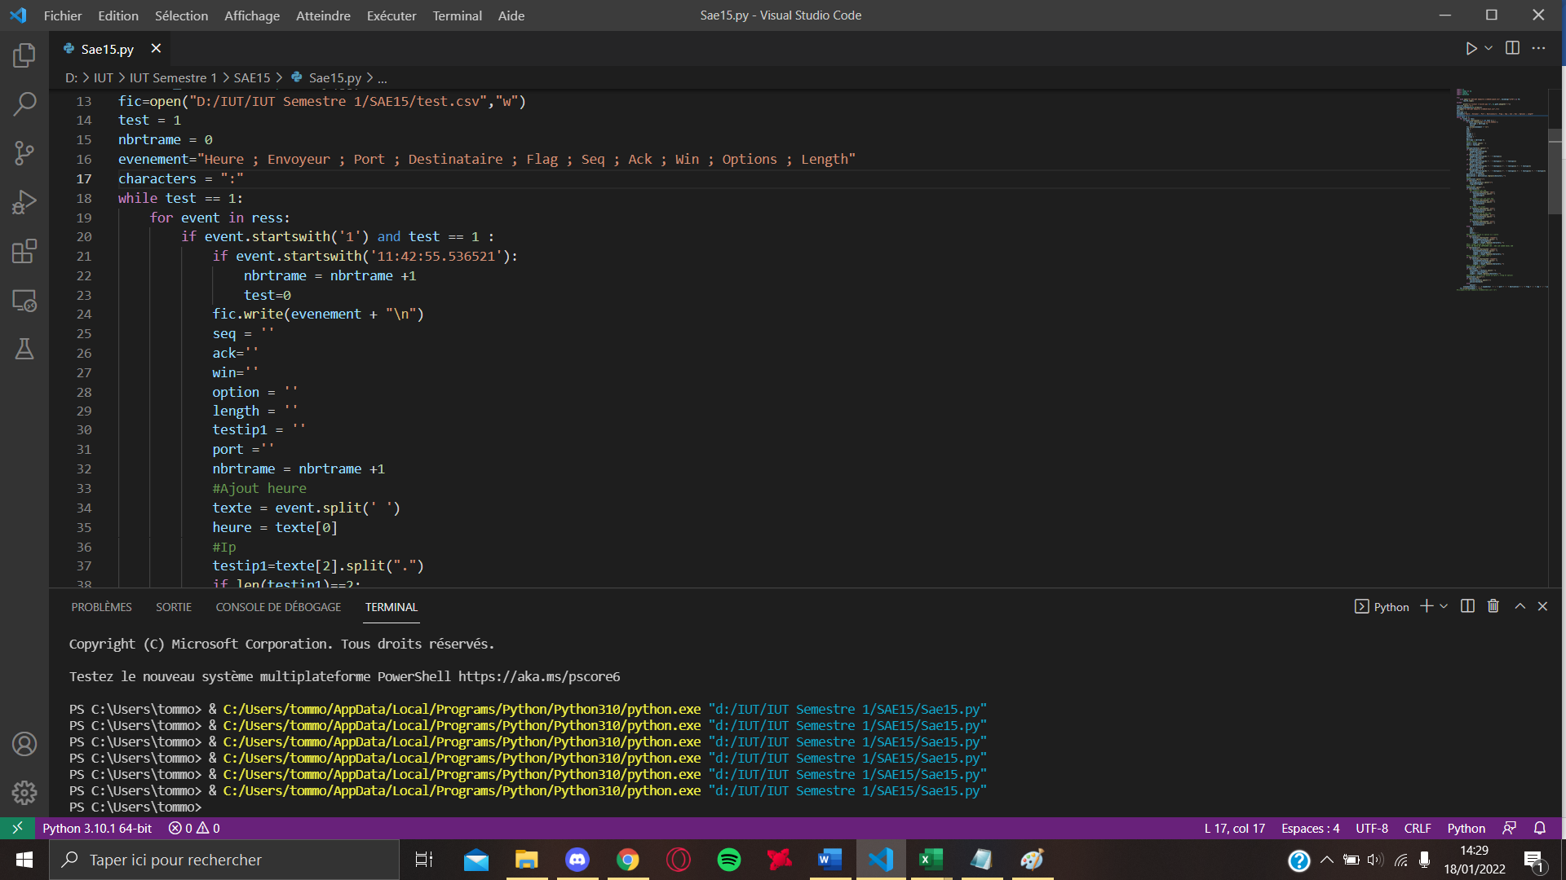

**Step 2: Open the Excel file**

1. **Using a Macro**

*If you encounter a problem while using the Macro, go to part 2 or I show you how to do the work of the macro has its place.*

* Go to the developer tab, and click on "Visual Basic"

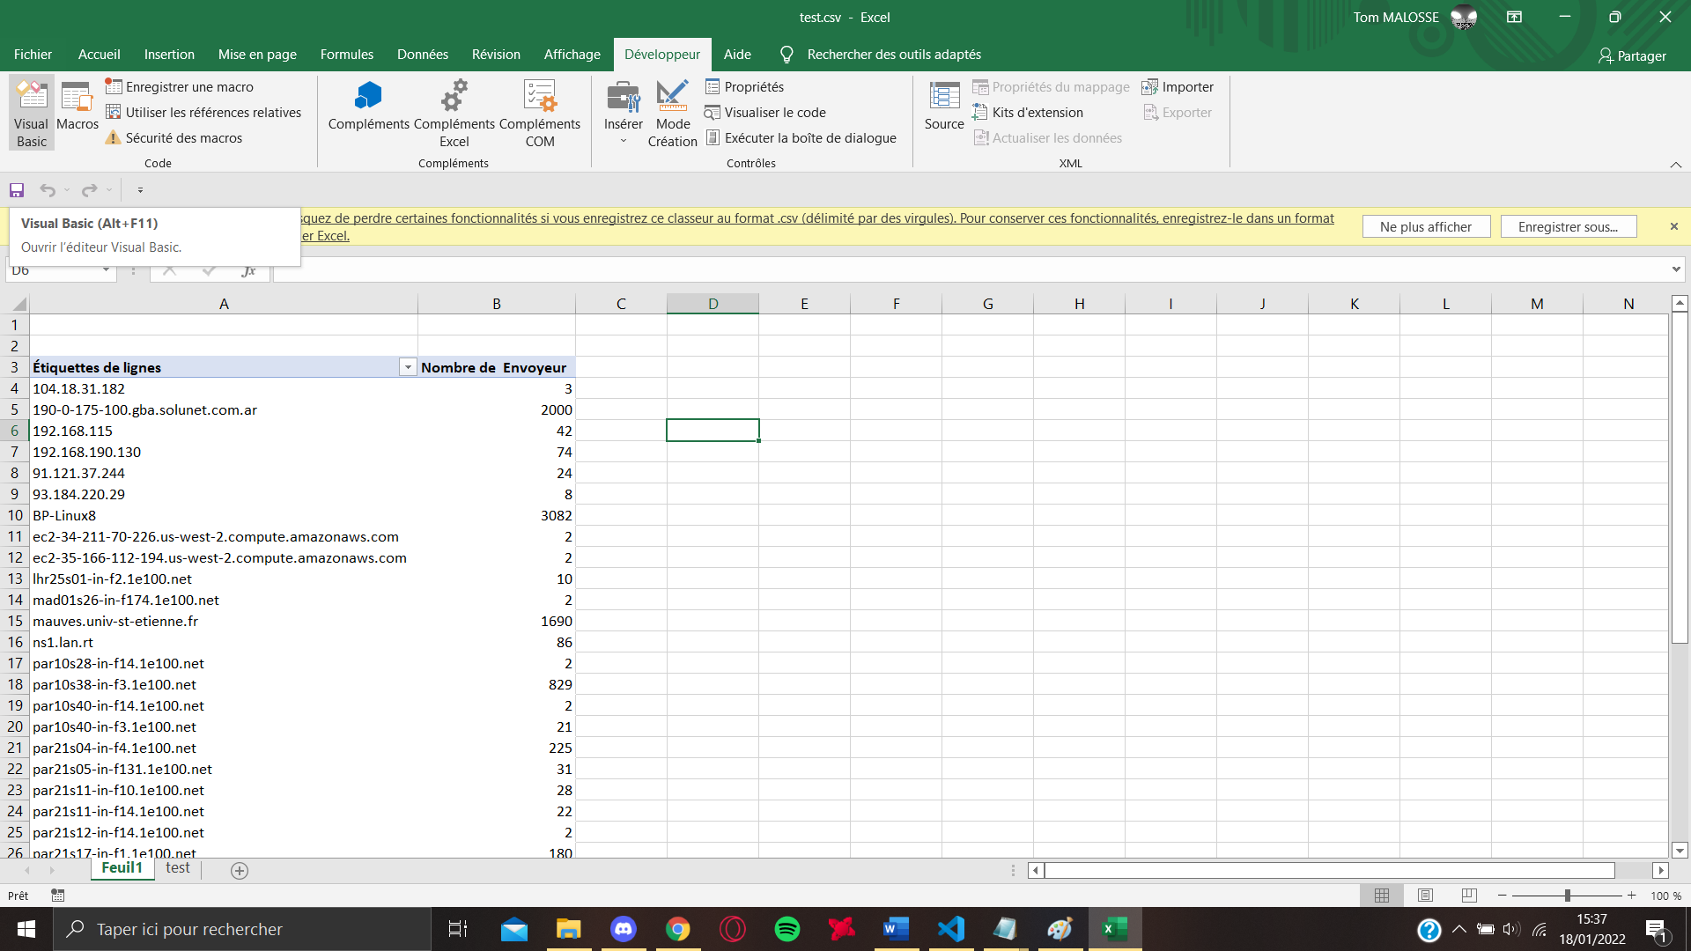

* Import a file

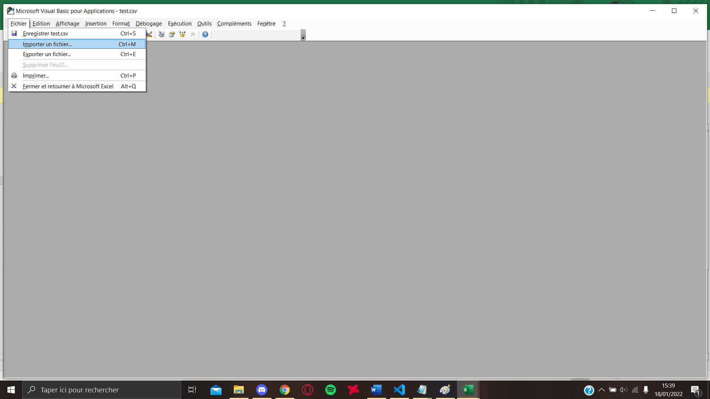

And select the provided .bas file

* You can closethis window, go back to the category develop and click on "macro", you must see the macro sorting previously install

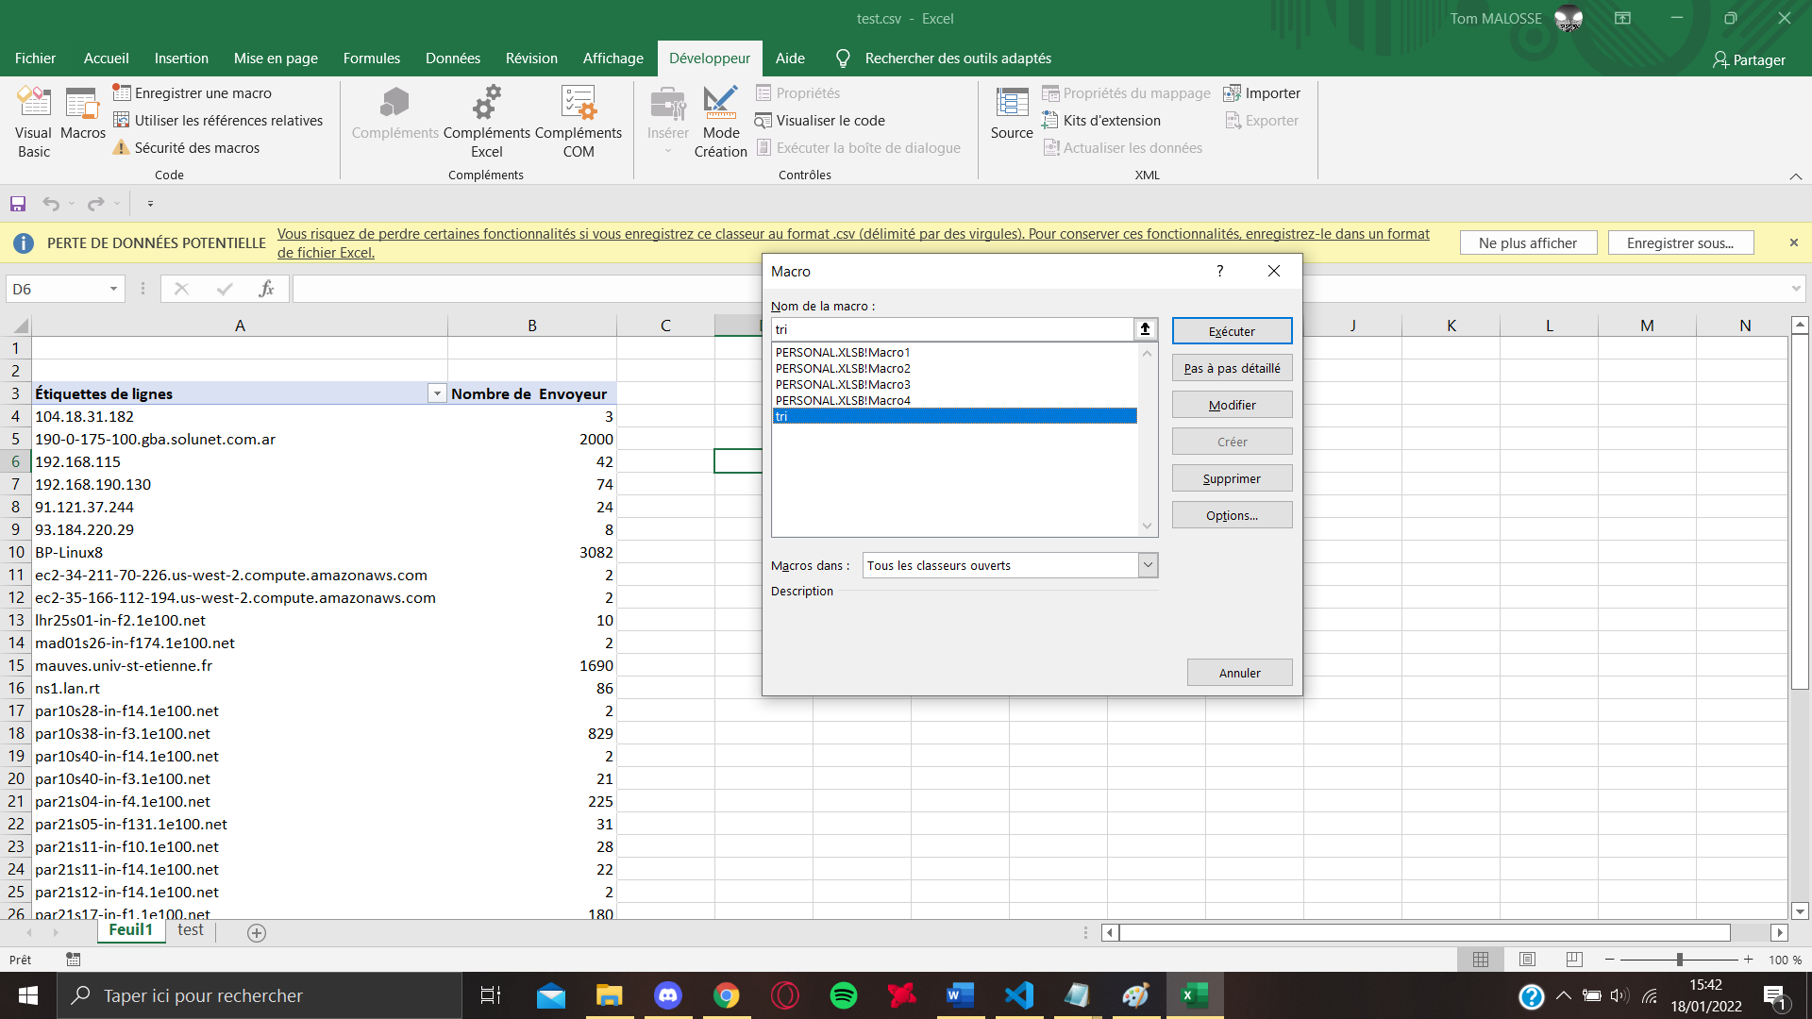

Run there and you should see a table with the different IP addresses and the number of times they have been used:

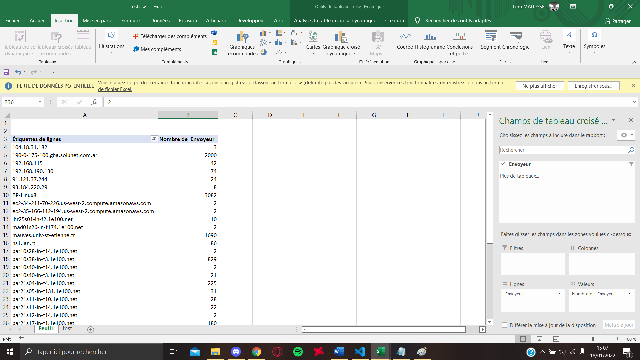

1. **If the Macro does not work**

* A file in .csv was normally created if you met the previous conditions, you will now have to open it
* First clicked on the column that interests us (here B) and clicked on format table

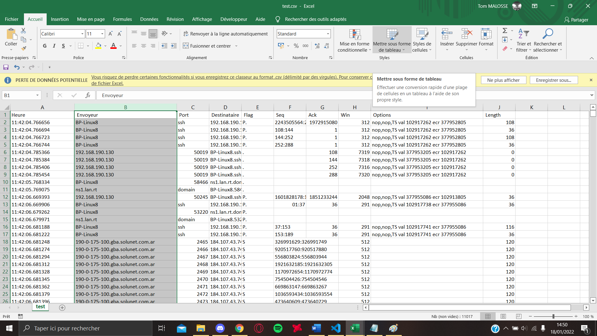

Choose the style you want, it doesn't matter

Then don't forget to check the box below

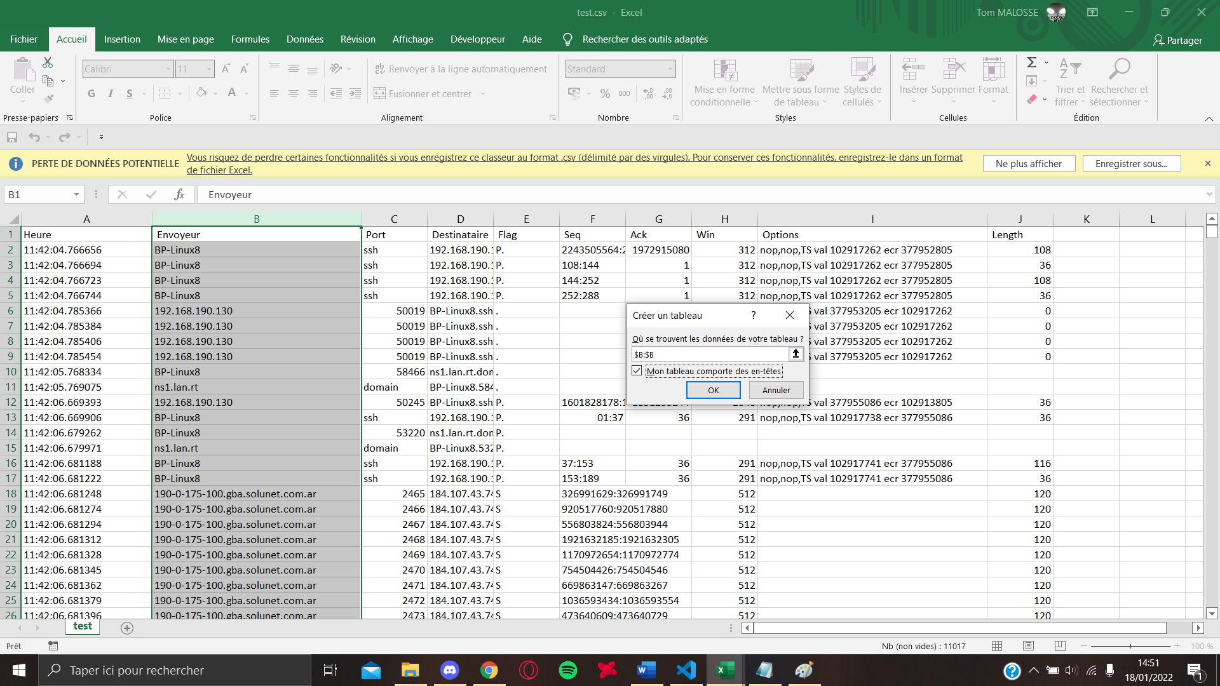

* Click OK and your column will be in table form
* Click on the arrow that will appear on the "sender" header to display filtering options and uncheck "empty"

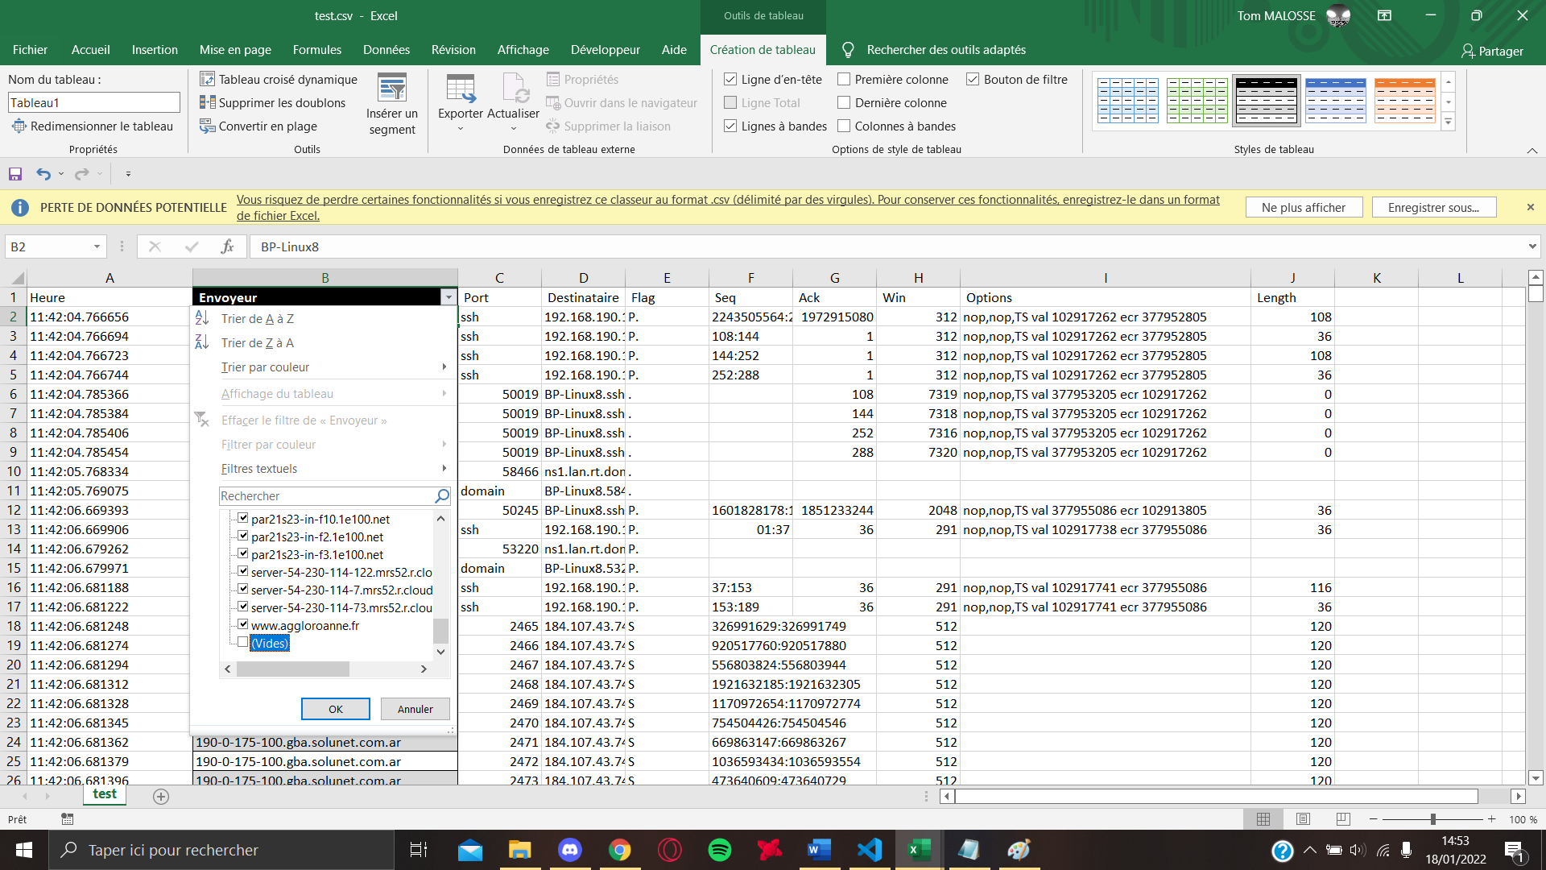

* Click OK
* Click the Sender box and then in the Insert category click PivotTable

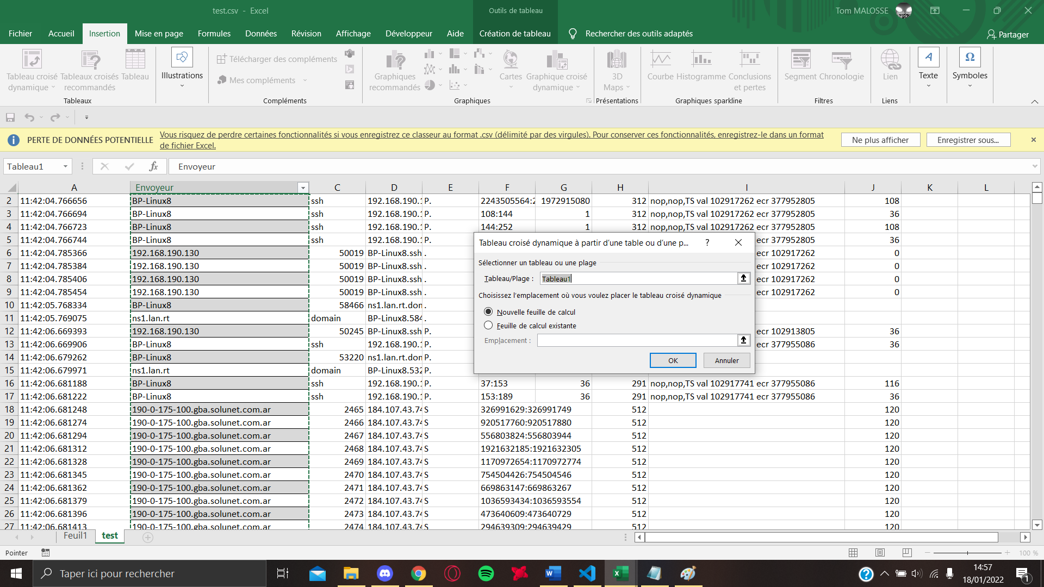

This message will then appear, click OK

* A new card has been created, go to it and click on the table which is the only thing you see on the spreadsheet and check the sender box

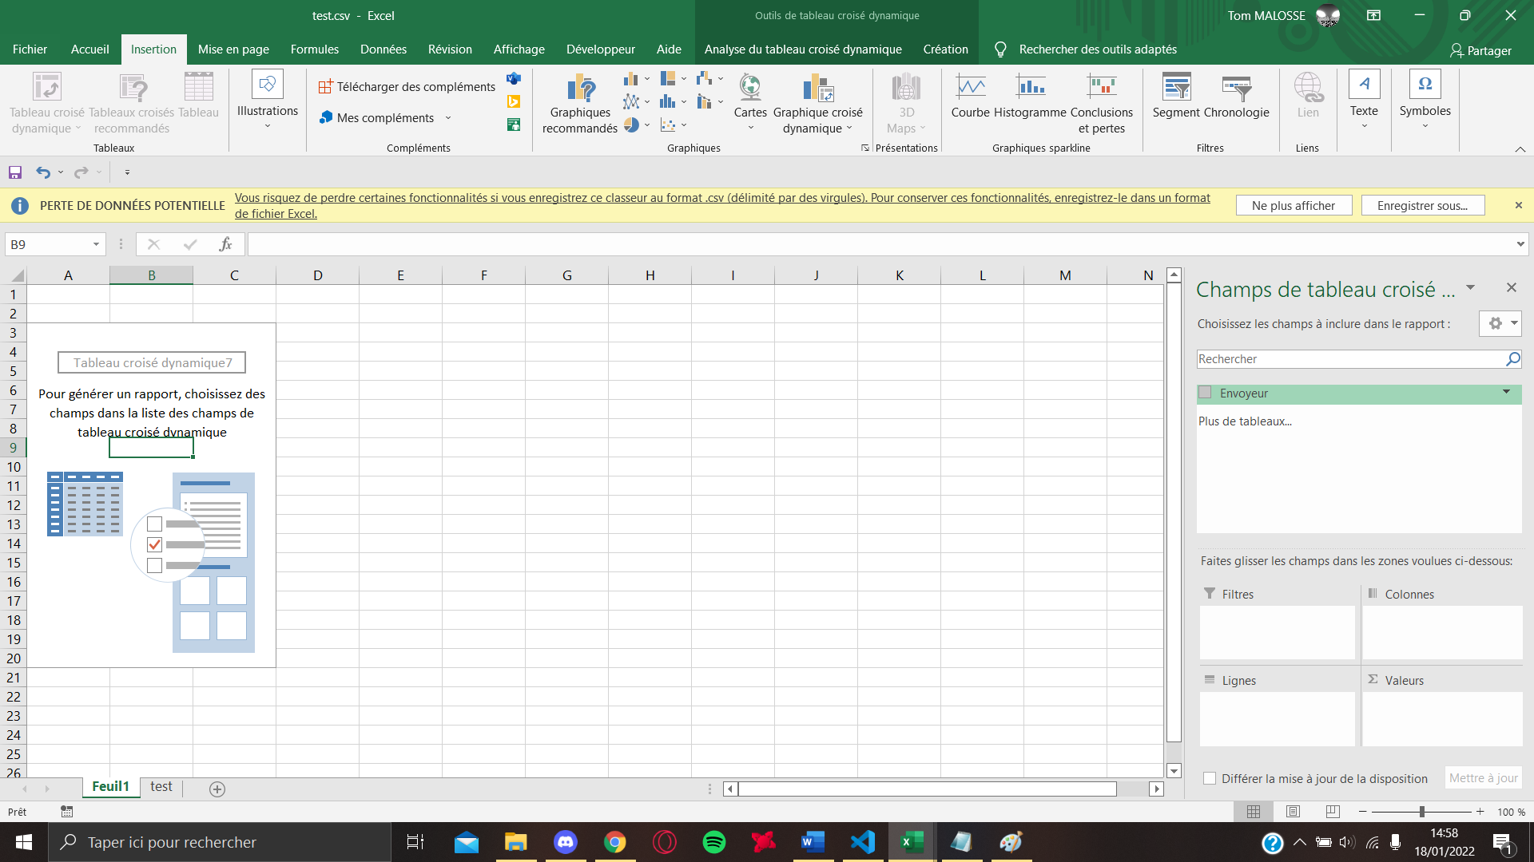

If this was not done automatically when you click-drop "sender" in the rows category

* Redo a click drop but this time drop it in values

If this is not already done basic, click on the "sender" that you have put in many

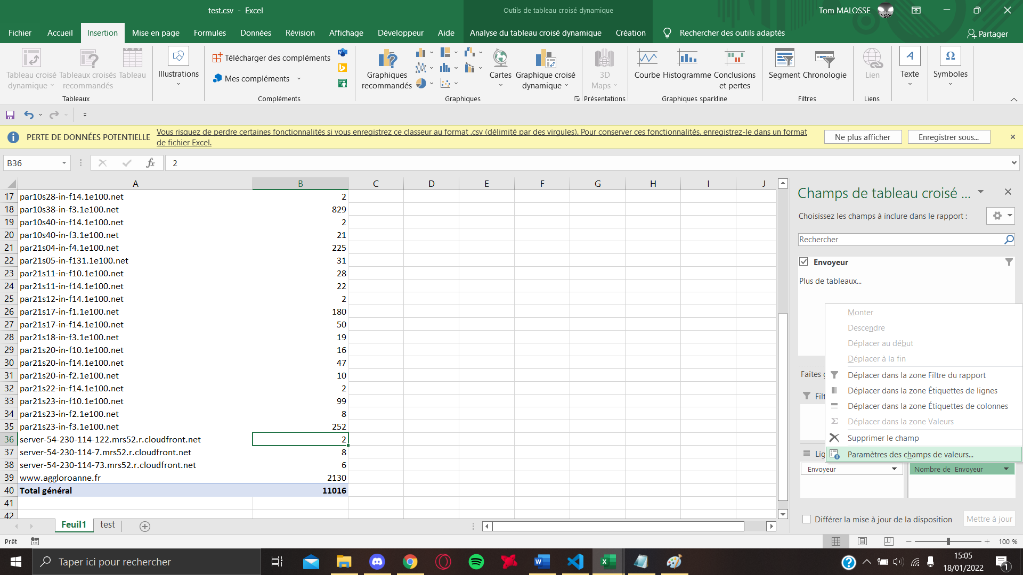

Go to Value Field Settings

And select number

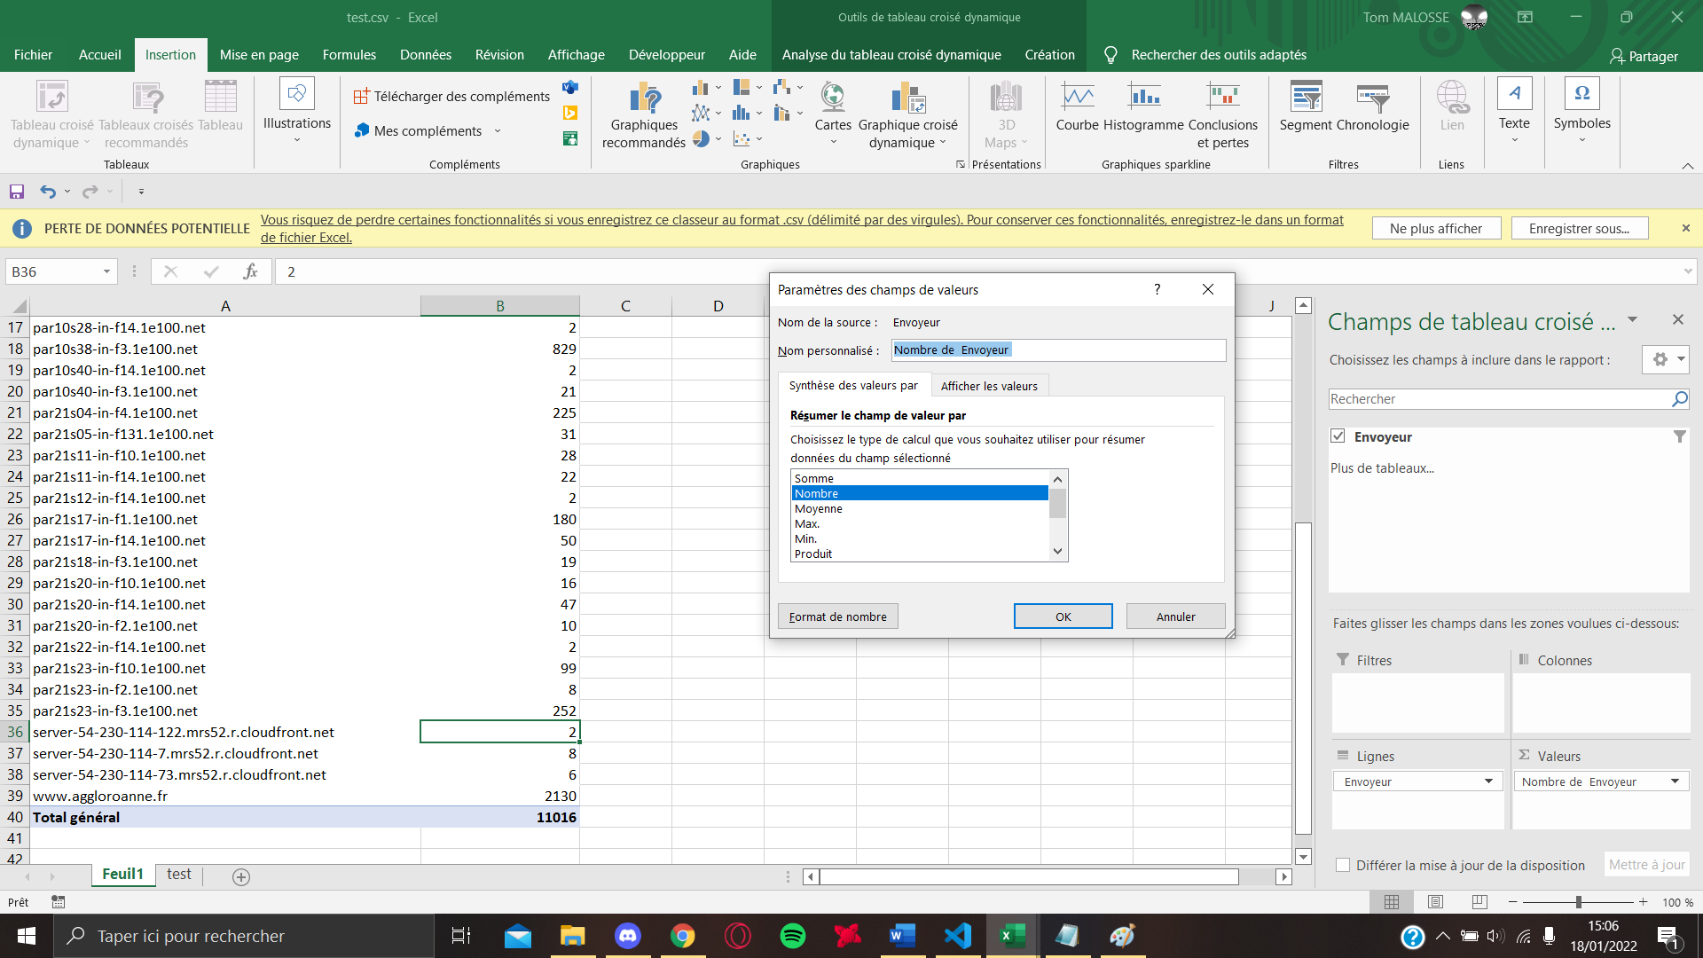

* You have now a list of all the different IP addresses that appear in the trâmes and how often they appear

